Walid Abou El Hosen

ID: 202473080

Visualization on Streamlit App:

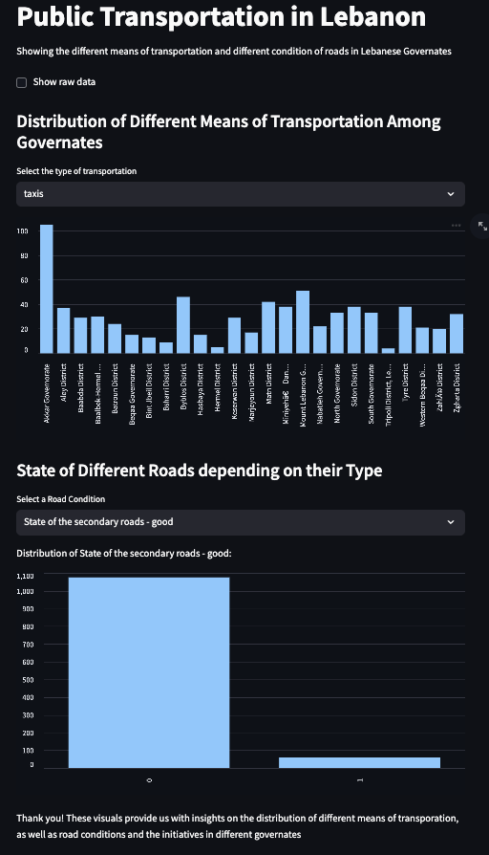

Link of App: